
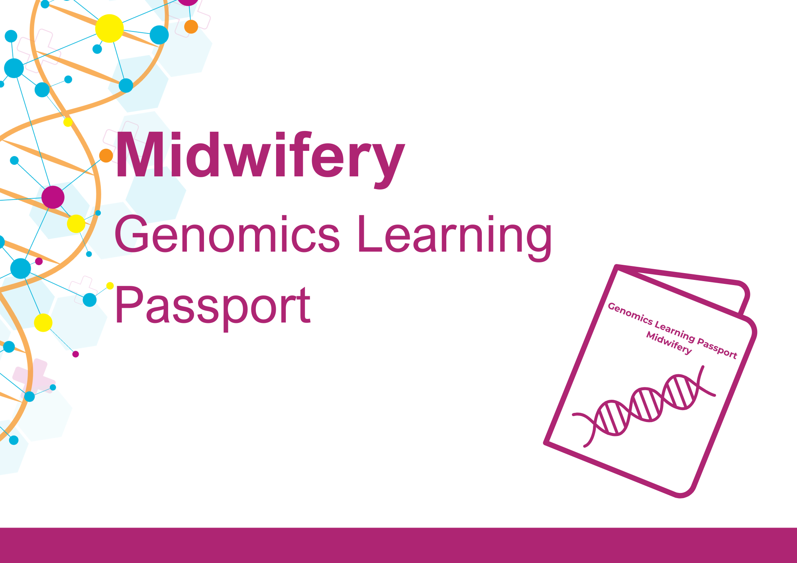
Developed by Central and South Genomic Medicine Service Alliance
Your personal record of genomics learning

Genomics underpins many aspects of your practice as a midwife. From taking a family history, referring for specialist advice, offering screening or initiating specific tests, genomics can help you to predict and prepare for situations during pregnancy, labour, birth, and neonatal care. Genomics is now included in the Nursing & Midwifery Council (NMC) standards of proficiency for midwives, so it’s important that all midwives are able to talk about genomics with confidence. There are a range of education and training resources to support your genomics learning, whether you are starting at the beginning and want to understand the core concepts, or are ready to study at Master’s level. It can be confusing to know where to start, so the Genomics Learning Passport has been designed to guide you through the key educational resources currently available and record your genomics learning journey in a format that meets requirements for revalidation.
The Passport is divided into three parts:
Part 1: For all midwives. This section covers the essentials and core concepts in genomics that all midwives should be aware of.
Part 2: For midwives in specialist roles or those who have an interest in genomics. This section includes more specialist learning.
Part 3: Where to find out more: further resources / websites / other sources of information to progress your self-directed learning.

Use of the Passport is not mandatory; however, we recommend all midwives complete the resources listed in part 1 to provide a basic understanding of genomics that supports the requirements of the NMC standards. We suggest that all the resources in part 1 are completed over a two-year period.
The Passport is based on the NMC CPD activity log so that you can use this record of learning for your revalidation. You can edit the log to include any additional learning undertaken, to create your own bespoke genomics learning journey. When undertaking revalidation, we advise that you always refer to the latest guidance at https://www.nmc.org.uk/revalidation/.
We welcome your feedback!
If you would like to share your experience of using the Passport, suggest additional content or want to report any errors such as broken hyperlinks, then please contact the Passport development team at Central and South Genomic Medicine Service Alliance: GMSAAdmin@uhb.nhs.uk

Genomics Learning Passport for Midwives
Name |  | NMC number
Job Title |  | Date revalidation next due
Place of work

Guide to completing the Passport to meet the CPD requirements for revalidation. For further information on CPD and revalidation, please refer to Continuing professional development - The Nursing and Midwifery Council (nmc.org.uk)
Examples of learning method:  - Online learning  - Course attendance  - Independent learning | Topic(s):  What was the topic? Please give a brief outline of the key points of the learning activity, how it is linked to your scope of practice, what you learnt, and how you have applied what you learnt to your practice. | Link to the NMC Code:  Please identify the part or parts of the Code relevant to your CPD.  - Prioritise people  - Practise effectively  - Preserve safety  - Promote professionalism  and trust | Link to NMC standards of proficiency:  Please identify the part or parts of the relevant standards that you used to inform your CPD.

Genomics Learning Passport for Midwives: PART 1
Baseline essentials and core concepts
Online learning resources that provide a baseline understanding of genomics as required by all midwives.
 | Dates | Methods: Please describe the methods you used for the activity | Topic(s) | Link to NMC Code | Link to Standards  of Proficiency | Number of hours | Number of  participatory  hours
Where to begin? NHS England’s Genomics Education Programme (GEP) has a wide range of resources, from short films on core concepts to information about studying at Master’s level. We introduce you to the key resources for midwives below.

A good place to start your genomics learning journey is the Genomics in Midwifery page. We suggest that you review this content and record that you have completed this activity for your revalidation below. [About 15 minutes]
Genomics in Midwifery - Genomics Education Programme
Online /independent learning
 | Not sure of the difference between genomics and genetics? Need a refresher on DNA? The following module revisits the basics. [About 15 minutes]
What is genomics?- Genomics Education Programme
Online learning
Epigenetics: All midwives should be aware of ‘epigenetics’, which is now referred to in the standards-of-proficiency-for-midwives.pdf (nmc.org.uk)
This bite-sized learning module introduces you to the basics of epigenetics. [10-20 minutes]
What is epigenetics?-Genomics Education Programme
Online learning
Genomics Education Programme: Genomics 101
Genomics 101 is a collection of online courses developed by the GEP to support and educate healthcare professionals about genomic medicine and the benefit it is bringing to patient care. Free to all NHS staff once registered with the e-Learning for Healthcare platform.
Dates: |  | Methods: Please describe the methods you used for the activity | Topic(s): | Link to NMC Code: | Link to Standards  of proficiency: | Number of hours: | Number of  participatory  hours:
Genomics in Healthcare
(30 mins)
From Genes to Genome
(30 minutes)
From Gene to Protein
(30 minutes)
Inheriting Genomic Information
(30 minutes)
Dominant, Recessive and Beyond: How Genetic Conditions are Inherited
(30 minutes)
Taking and Drawing a Genetic Family History
(40 minutes)
Talking Genomics: Tips and Tools for Communicating with Patients
(30 minutes)
Investigating the Genome Part 1: The Process
(30 minutes)
Investigating the Genome Part 2: The Tests
(30 minutes)
 | These two online learning modules, available at the NHS Learning Hub, explore the genetic risk in close relative marriage (consanguinity and endogamy) and equitable access to clinical genomic services. Each module takes approximately 30-40 minutes.
Close relative marriage, genetic risk and equitable access to clinical genomics services
(~40 mins)
Close relative marriage and genetic risk: your role as a midwife
(~40 mins)
 | Pharmacogenomics: All midwives should be aware of the developing field of pharmacogenomics. Here is an introduction to the subject:
Introduction to pharmacogenomics (GeNotes)
(15 mins)
 | NHS ANNB Screening Programmes: Genomics is relevant to many of the six NHS Antenatal and Newborn screening programmes: For example, in Sickle Cell and Thalassaemia, Fetal Anomaly and all the Newborn Screening Programmes. Online modules for all programmes are available at NHS Screening Programmes – e-learning for healthcare (e-lfh.org.uk). You may want to record these in the table below once completed.
Dates: |  | Methods: Please describe the methods you used for the activity | Topic(s): | Link to NMC Code: | Link to Standards  of proficiency: | Number  of hours: | Number of  participatory  hours:
 | (Please add rows as necessary to record all your genomics learning activity) |  |  |  |  | Total: | Total:

Congratulations on completing part 1 of the Genomics Learning Passport for Midwives!
If the courses in Part 1 have inspired you, or you are in a specialist role, why not move on to Part 2 to progress your genomics learning journey.
Further resources are also listed in Part 3, where you are invited to submit feedback on your experience of using this Passport.

Genomics Learning Passport for Midwives: PART 2
For midwives in specialist roles or who have a particular interest in genomics
The following modules may be more suited to specialist midwives or anyone with an interest in genomics who wants to take their learning further. There is no suggested timeframe in which to complete these modules. You may not need to complete all modules – you will need to decide which modules are appropriate to your sphere of practice or learning requirements. You can also add any additional learning undertaken at the end of the table.
 | Facilitating Genomic Testing is a suite of five online modules, developed by the GEP, that explore the National Genomic Test Directory. The modules include information about the National Genomic Research Library, discussion and offer of genomic tests, and data storage. A certificate of completion is available for each module. These are particularly suitable for specialist midwives who are supporting people undergoing genomic testing. Each module takes around 30 minutes.
Dates: |  | Methods: Please describe the methods you used for the activity | Topic(s): | Link to NMC Code: | Link to Standards  of proficiency: | Number  of hours: | Number of  participatory  hours:
Introduction to Offering Genomic Tests
(30 minutes)
Discussing Diagnostic Germline Diagnostic Genomic Tests
(30 minutes)
Discussing Targeted Germline Genomic Tests
(30 minutes)
The National Genomic Research Library
(30 minutes)

Data and Sample Management in the NHS Genomic Medicine Service
(30 minutes)

 | Genomics in Clinical Practice: A work-based learning module comprises 3 sessions and is available on the NHS Learning Hub. Relevant for specialist midwives or anyone who wants to explore genomics further, these modules help embed the theory learned in part 1 of the Passport and apply it to clinical practice. The sessions were developed by the University of Liverpool and Liverpool Women’s NHS Foundation Trust.
 |  | Genomics in Clinical Practice – Session 1: The Cell and Genomics
 |  | Genomics in Clinical Practice – Session 2: Genetic Conditions- Identifying Pathways and Developing Your Own Professional Resources
 |  | Genomics in Clinical Practice – Session 3: Reflective Practice and Competence Practice: Your Learning Portfolio
 | Patient Choice: Discussing whole genome sequencing is on the NHS East Genomics e-learning platform. It is particularly relevant for anyone caring for families where whole genome sequencing may be offered for a suspected rare, inherited condition in a baby.
 |  | Patient Choice: Discussing whole genome sequencing
Dates: |  | Methods: Please describe the methods you used for the activity | Topic(s): | Link to NMC Code: | Link to Standards  of proficiency: | Number  of hours: | Number of  participatory  hours:
FutureLearn: online courses and degrees from universities
There are a variety of courses on FutureLearn relevant to midwifery and genomics. New courses are being added to the platform all the time, so take a look to see what is currently available. Many of these courses are free to access if completed within a specified timeframe. The following courses may be useful for specialist midwives and anyone who wants to explore genomics further:
Genomics in the NHS: A Clinician’s Guide to Genomic Testing for Rare Disease
Developed by the GEP and St George’s University
(2 weeks, ~3 hours per week)
Genetic Inheritance for the Pregnancy Pathway: a Practical Guide for Clinicians
Developed by St George’s University
(2 weeks, ~3 hours per week)
Monogenic Diabetes within Maternity Services This course, developed by the NHS South East and East Genomic Medicine Service Alliances and hosted on the NHS Learning Hub, is appropriate for midwives working with or interested in diabetes.
 |  | Monogenic Diabetes within Maternity Services
Further information and training on monogenic diabetes, including pregnancy and neonatal-specific information, is available on the Diabetes Genes website. Add any courses or training undertaken to your Passport above. It is also worth checking FutureLearn, which occasionally runs courses on monogenic diabetes.
 | Observation of genetic counselling session: For midwives involved in counselling pregnant women, pregnant people, their partners and families about genomics, it might be helpful to observe a clinic with a genetic counsellor or clinical geneticist. Contact your local clinical genetics service to arrange a session and record your experience as a learning activity below or write a reflective piece.
(Please add rows as necessary to record all your genomics learning activity) |  |  |  |  |  | Total: |  | Total:

Congratulations on completing part 2 of the Genomics Learning Passport for Midwives!
You can of course continue to add additional learning activities to your Passport and new courses are being developed all the time.
Further resources are also listed in Part 3, where you are invited to submit feedback on your experience of using this Passport.

Genomics Learning Passport for Midwives: PART 3
Further resources: where to find out more
Part 3 contains information on further education, resources to support you in your clinical practice, key documents on equality and diversity, key NHS policy documents, resources for educators, useful websites, and who to contact if you want to know more.
Take your study to the next level: choose from single CPPD modules, postgraduate certificates or diplomas, or a full Master’s degree in Genomic Medicine.
If you have completed some or all of the courses listed above and want to learn more, there are a range of accredited postgraduate taught courses, ranging from single CPPD modules, postgraduate certificates and diplomas, up to a full Master’s degree. More information is available on the GEP website. Funding may also be available for one or more modules to support your learning.

See also ’Popular funded genomics course returns’ for details of the online Genomics and Counselling Skills module developed by the GEP and University of West England. Aimed at healthcare professions including midwives, the course aims to develop knowledge and understanding of genomics to better support people in their care.
Clinical resources: supporting you in your clinical practice
The following resources, developed by the GEP, are available to support you in your clinical practice. If you have used any of these resources, you can add a review of the resource to the CPD log above. Why not write a reflective piece about your experience of using these resources for your revalidation? You can use the NMC reflective account form.
GeNotes: Genomic notes for clinicians | GeNotes has been developed to support your understanding of genomics in clinical practice. The resource comprises two tiers of content: In the Clinic (concise scenarios on when, why and how to request genomic testing and feed back results) and the Knowledge Hub (an encyclopaedia of supporting educational resources).
GeNotes: Fetal and Women's Health | GeNotes includes a dedicated Fetal and Women’s Health section, providing practical educational scenarios and further learning.
GeNotes: Paediatrics | There is also a dedicated paediatrics GeNotes section.
Taking and drawing a family history | This collection of useful resources on how to take and draw a genetic family history features useful diagrams, short training videos, FAQs, and a worksheet to practise drawing a genetic family history.
Equality and diversity in genomics
The following resources are a good starting point for understanding some of the issues relating to equality and diversity in genomics. We suggest you review these resources, record your learning in the log above and consider writing a reflective piece for your revalidation. You can use the NMC reflective account form.
Genomics England  The Genomics England Diverse Data Initiative aims to reduce health inequalities and improve patient outcomes in genomic medicine for minoritised communities. This includes a focus on improving our understanding on the role of genes in driving maternal health outcomes, for example with pre-term birth and pre-eclampsia. |  | Diverse Data | Genomics England  Maternal health | Genomics England
NHS Race and Health Observatory  Published in 2024, this landmark NHS Race and Health Observatory report aims to provide an understanding of how precision medicine services, genomic testing and genomics research are accessible to and involve people from different ethnic minority groups. |  | Ethnic inequities in genomics and precision medicine review report - NHS – Race and Health Observatory (nhsrho.org)

Teaching resources
The following resources have been developed by the GEP to support clinicians with their teaching activities. If you have used any of these resources, why not write a reflective piece about your experience of using it for your revalidation or add it to the CPD activity log above? You can use the NMC reflective account form.
The Genomics Game quiz | A PowerPoint presentation quiz-styled teaching resource, based on The Genomics Game. Developed by the GEP, this is a fun way to explore genetics and genomics concepts as well as how they’ll be encountered in a modern healthcare system. Slides can be used as an add-on to existing teaching materials or as a standalone activity.
Genomics Game factsheets | A collection of factsheets designed to accompany the Genomics Game [above] as handouts after the session. However, they can also be used as preparation materials or post-session handouts for other teaching sessions.
Image library | The GEP image library is available for download and use in your work as long as it is for non-profit purposes and you credit the source. See the website for further details.
Nursing educator’s toolkit | Case studies to support the delivery of genomics education to pre-registration nurses (adult and child). Includes stories relevant to midwifery. A midwifery educator’s toolkit is under development.

Useful websites:
National Genomic Test Directory | The National Genomic Test Directory specifies which genomic tests are commissioned by the NHS in England, the technology by which they are available, and the patients who will be eligible for a genomic test.
Genomics England | Genomics England works in partnership with the NHS to provide whole genome sequencing diagnostics and leads on some research projects, such as the Newborn Genomes Programme.
Newborn Genomes Programme | The latest information on the Newborn Genomes Programme and the Generation Study.
Diabetes Genes | Everything you need to know about monogenic diabetes.
Royal College of Midwives: RCM i-learn | i-learn is the RCM’s e-learning platform. It has modules to support your practice as a midwife; however, these are only available to RCM members. The following modules are relevant for genomics:  - Genetics and genomics for midwifery practice (1 hour)  - Delivering unexpected news in pregnancy (1 hour)  If you complete these modules, add them to your record of learning above.

Genomics and the NHS
A series of documents have been published that outline the role of genomics in our future NHS. Have a read of the following documents and consider writing a reflection for your revalidation.
NHS Long Term Plan [2019] – NHS England
Genome UK: the future of healthcare [2020] – HM Government
Accelerating genomic medicine in the NHS [2022] – NHS England
Genomic Medicine Service Alliances (GMSAs)
There are seven GMSAs in England. Each GMSA has a lead midwife and/or director of nursing and midwifery in post. Contact your GMSA direct if you want to know more about what is happening in your area and if you have any questions about genomics education. See websites for contact details:
NHS Central and South GMSA | https://centralsouthgenomics.nhs.uk/
NHS East GMSA | https://www.eastgenomics.nhs.uk/
NHS North East and Yorkshire GMSA | https://ney-genomics.org.uk/
NHS North Thames GMSA | https://norththamesgenomics.nhs.uk/
NHS North West GMSA | https://www.nw-gmsa.nhs.uk/
NHS South East GMSA | https://southeastgenomics.nhs.uk/gmsa/
NHS South West GMSA | TBC – under construction
Feedback
We welcome your feedback. Please contact us to:
- share your experience of using the Passport;
- advise of content that is missing or new content that could be included in a future edition; and
- report any errors, such as broken hyperlinks.
Please contact the Passport development team by email at: GMSAAdmin@uhb.nhs.uk

