
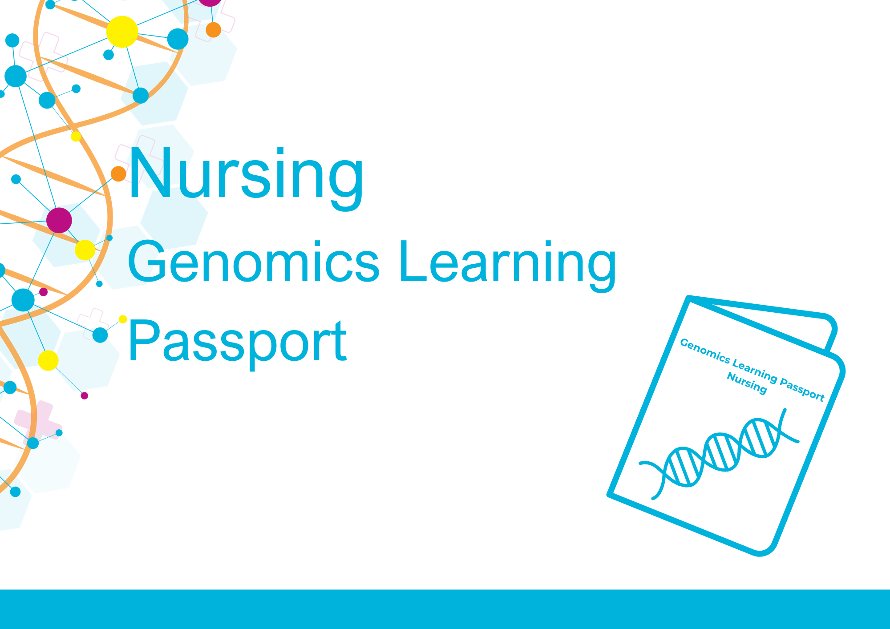

Developed by Central and South Genomic Medicine Service Alliance
Your personal record of genomics learning
The ever-evolving field of genomics is transforming patient care across the NHS, including diagnosing illnesses, predicting disease risks, and tailoring treatments to enhance efficacy while minimising adverse effects. It is imperative that all nurses possess role-appropriate knowledge of genomics, enabling them to confidently integrate genomics into patient care, as outlined in the Nursing & Midwifery Council (NMC) standards of proficiency for registered nurses. The NHS recognises the significance of genomics education for healthcare professionals and it is featured in a number of strategies (see ‘Recommeded reading’, page 14).
Embarking on a genomics learning journey can sometimes be overwhelming. To assist you on this path, the Genomics Learning Passport has been developed to guide you and evidence your learning. It is not a competency document; however, it can help you to acquire the necessary knowledge to meet the competencies outlined in the Genomic Competency Framework for Nurses.
Whether you are just starting to explore core concepts or are ready to delve into Master's-level studies, there are education and training resources available to suit your needs. The Passport can be edited to include any additional learning, to create your own bespoke genomics learning journey. Towards the end of this log, there is a list of websites and additional sources of information to facilitate your self-directed learning, including links to the national strategies.
The Passport is divided into four parts:
Part 1: For all nurses. This section covers the basic concepts of genomics necessary for clinical practice.
Part 2: For nurses who have some experience of genomics or wish to build upon the basic knowledge.
Part 3: For nurses with extensive genomics knowledge to integrate genomics into clinical practice.
Part 4: Further information and resources to direct learning beyond the Passport
The passport is not mandatory. However, it is recommended that all nurses complete the resources listed in the basic section to provide a fundamental understanding of genomics, which supports the requirements of the NMC standards.
We welcome your feedback!
If you would like to share your experience of using the Passport, suggest additional content or want to report any errors such as broken hyperlinks, then please contact the Passport development team.

Genomics Learning Passport for Nurses
Name |  | NMC number
Job title |  | Date revalidation next due
Place of work

Guide to completing your learning record
This tool is designed to navigate you through the wealth of available resources, document your genomics learning journey and help support your revalidation process.
The Passport has been divided into basic, intermediate and experienced sections to address different levels of genomics learning. This will allow you to progress at your own pace, gradually expanding your knowledge as you advance. It is based on the NMC CPD activity log so that this record of learning can be used for your revalidation.
Each part within the Passport is structured the same for consistency and ease of use and is shown in the table below.
Name of resource and method of learning  - Online learning  - Course attendance  - Independent learning | Overview of topic/  resource content  - Please give a brief summary of the information covered and key points | Scope of practice  - Provide an overview of its relevance to your scope of practice, the knowledge gained, and how you have or will integrate this into your practice.  - Alternatively, reflect on the connection between the learning activity and your practice, and your ability to apply what you have learned. | Link to NMC Code  - Identify the part or parts of the Code relevant to your CPD.  - Prioritise people  - Practise effectively  - Preserve safety  - Promote professionalism  and trust | Link to Standards of Proficiency (SoP) and/or Genomic Nursing Competency Framework (GNCF)  - SoP: Identify the part or parts of the relevant standards that you used to inform your CPD.  - GNCF: Align to the competency framework to ensure that the knowledge you gain is targeted, relevant and effective in your practice.

Record of learning
The following tables list the available learning resources relevant to nursing. NHS England’s Genomics Education Programme is the source of many of the resources; other sources are named individually.
There are too many courses to list them all below, so we have just included some of the key resources that are most relevant to nursing practice to get you started on your genomics learning journey. You can also add any additional learning at the end of the log
* Items starred below are in the Genomics 101 series of 9 short (30-40-minutes) online modules, which explain core concepts in genomics and how to apply these to your clinical practice. As certificate of completion is available for each course. Access via the links below or visit e-Learning for Healthcare, free to NHS colleagues once registered.
PART 1: Genomics Learning Passport for Nurses: Baseline essentials – core concepts of genomics
Online learning resources that provide a baseline understanding of genomics as required by all nurses.
Date | Name of resource and method of learning | Overview of topic/resource content | Scope of practice | Link to ⁷ NMC Code | Link to Standards of Proficiency(SoP)/Genomic Nursing Competency Framework(GNCF) | No. of hours

Glossaries:

Genomics Glossary

(webpage)
Talking Glossary
(Genome.gov webpage)
 | Bitesize Genomics: What is genomics?  (webpage, 10 minutes) | ^{Example}  (Definitions of genomics, DNA, genes, and how genomic data is used) | ^{Example}  (Understand how a person’s genome can affect their health and how the NHS can use their genomic data to make a diagnosis and identify possible treatments) | ^{Example}  (Prioritise people  Practise effectively  Preserve safety  Promote professionalism and trust) | ^{Example}  (SoP - Platform2  Platform 3  GNCF - 1, 4, 5, 7) | 10 min

Genomics in Nursing

(webpage)

*Genomics in Healthcare

(e-learning, 30 minutes)

*From Gene to Protein

(e-learning, 30 minutes)

*From Genes to Genome
(e-learning, 30 minutes)

*Inheriting Genomic Information

(e-learning, 30 minutes)

*Dominant, Recessive and Beyond (elearning)

(e-learning, 30 minutes)

DNA test diagnosis

(BBC video and article, 2 minutes)

Congratulations on completing part 1 of the Genomics Learning Passport for Nurses!
If Part 1 has inspired you to continue building your knowledge, why not move on to Part 2 to progress your genomics learning journey?

PART 2: Genomics Learning Passport for Nurses: Intermediate genomics learning
The following modules may be more suited to clinical nurse specialists or anyone with an interest in genomics who wants to take their learning further. There is no suggested timeframe in which to complete these modules. You may not need to complete all modules – you will need to decide which modules are appropriate to your sphere of practice.
Date | Name of resource and method of learning | Overview of topic/resource content | Scope of practice | Link to NMC Code | Link to Standards of Proficiency/Genomic Nursing Competency Framework | No. of hours
*Taking and Drawing a Genetic Family History
(e-learning, 40 minutes)
*Talking Genomics: Tips and Tools for Communicating with Patients
(e-learning, 30 minutes)
*Investigating the Genome
Part 1: The Process (elearning)
(e-learning, 30 minutes)
*Investigating the Genome
Part 2: The Tests (elearning)
(e-learning, 30 minutes)
Introduction to pharmacogenomics
(GeNotes article)

Personalised medicine

(NHS England webpage)

Bitesize Genomics: What is epigenetics?

(webpage)
What is genetic variation?

(Your Genome webpage)

Four types of genetic testing explained
(article)
Facilitating Genomic Testing: Introduction to Offering Genomic Tests
(e-learning, 30 minutes)
Patient Choice for Whole genome sequencing
(slide deck)
Patient Choice: Discussing whole genome sequencing
(East Genomics Learning, e-learning, 30 minutes)
Taking Consent for
Genomic Testing
(NHS North East & Yorkshire Genomics, webinar, 60 minutes)
Guide for discussing whole genome sequencing for cancer
(factsheet)
Impact of whole genome sequencing
(British Journal of Cancer article)
Genetic counsellors
(video and supporting article,
4 minutes)
Confidentiality and genetic information
(British Society for Genetic Medicine, webpage)

Congratulations on completing part 2 of the Genomics Learning Passport for Nurses!
If you have substantial genomics knowledge, you may wish to move on to Part 3 to further build on your understanding and expertise.

PART 3: Genomics Learning Passport for Nurses: Specialist genomics learning
The following courses and resources may be more suited to nurses with substantial genomics knowledge to further expand your expertise, understanding and application of genomics. There is no suggested timeframe in which to complete these modules. You will need to decide which modules are appropriate to your sphere of practice.
Date | Name of resource and method of learning | Overview of topic/resource content | Scope of practice | Link to NMC Code | Link to Standards of Proficiency/Genomic Nursing Competency Framework | No. of hours
Genomics in the NHS: A Clinician’s Guide to Genomic Testing for Rare Disease
(FutureLearn course, 2 weeks at 3 hours per week)
Ethical, Legal and Social Issues in Applied Genomics
(funded CPPD Master’s-level 15-credit module, 6 weeks)
Pharmacogenomics
(Medicines Learning Portal online tutorial, 1-2 hours)
Facilitating Genomic Testing: Discussing Diagnostic Germline Genomic Tests
(e-learning, 30 minutes)
Facilitating Genomic Testing: Discussing Targeted Germline Genomic Tests
(e-learning, 30 minutes)
Facilitating Genomic Testing: Data and Sample Management in the NHS Genomic Medicine Service
(e-learning, 30 minutes)
Let’s talk about… Possible results
(video, 3 minutes)
National Genomic Research Library: Information for clinicians
(webpage)
Diverse Data
(Genomics England webpage)
Why is diversity important in genomics research?
(Genomics England video, 1 minute)
Ethnic Inequities in Genomics Report
(PDF)
(Please add rows as necessary to record your genomics learning)
Congratulations on completing part 3 of the Genomics Learning Passport for Nurses!
You can, of course, continue to add additional learning activities to your Passport and new courses are being developed all the time. Further resources are also listed in Part 4, including clinical and teaching resources, and useful websites.

Please note: We cannot list all the courses available in this Passport. Please contact the GMSA team if you would like advice on specific learning or think there is an area of genomics not covered by current courses.

PART 4: Genomics Learning Passport for Nurses: Further resources and where to find out more
Taking your study to the next level
If you have completed all the resources listed above that are relevant to you and want to continue advancing your learning, there are a range of accredited taught courses from single modules to postgraduate programmes. More information is available on the Genomics Education Programme (GEP) website. Funding may also be available for one or more modules.
See also ‘Popular funded genomics course returns’ for details of the online Genomics and Counselling Skills module developed by the GEP and University of West England. Aimed at healthcare professions including nurses, the course aims to develop knowledge and understanding of genomics to better support people in their care.
Clinical resources: supporting you in your clinical practice
The following resources are available to support you in your clinical practice. If you have used any of these resources, you can add a review of the resource to the CPD log above. Why not write a reflective piece about your experience of using it for your revalidation? You can use the NMC reflective account form.
GeNotes: Genomic Notes for Clinicians | NHS England’s Genomics Education Programme | GeNotes has been developed to support your understanding of genomics in clinical practice. The resource comprises two tiers of content: In the Clinic (concise scenarios on when, why and how to request genomic testing and feed back results) and the Knowledge Hub (an encyclopaedia of supporting educational resources).
National Genomic Test Directory | NHS England | The National Genomic Test Directory specifies which genomic tests are commissioned by the NHS in England, the technology by which they are available, and the patients who will be eligible to access each test.
Family History Template Tool | NHS England’s Genomics Education Programme | This handy tool can be used as a template to create genetic family tree diagrams and as a reminder of the questions to ask and the symbols to use. It can also be used as an educational tool.

Teaching resources
The following resources have been developed to support with teaching activities. If you have used any of these resources, why not write a reflective piece about your experience of using it for your revalidation or add it to the CPD activity log above? You can use the NMC reflective account form.
Nursing educator’s toolkit | Case studies to support the delivery of genomics education to pre-registration nurses (adult and child).
Facilitating genomic testing: a competency framework | This competency framework focuses on the knowledge, skills and behaviours needed to support a patient in considering and consenting to genomic testing. This involves a ‘patient choice’ model of consent, which covers both the clinical implications of a test as well as a research offer within a clinical pathway.
Genomics Game quiz | A PowerPoint presentation quiz-styled teaching resource, based on the Genomics Game. Developed by the GEP, this is a fun way to explore genetics and genomics concepts as well as how they’ll be encountered in a modern healthcare system. Slides can be used as an add-on to existing teaching materials or as a standalone activity.
Genomics Game factsheets | A collection of factsheets designed to accompany the Genomics Game as handouts after the session. However, they can also be used as preparation materials or post-session handouts for other teaching sessions.
Image library | The GEP image library is available for download and use in your work as long as it is for non-profit purposes and you credit the source. See the website for further details.

Useful websites
Genomics research | Genomics England homepage  Participant stories  Newborn Genomes Programme | Genomics England works in partnership with the NHS to provide whole genome sequencing diagnostics and leads on some research projects  Stories of how genomic testing, diagnosis and medicine has impacted the lives of participants in the 100,000 Genomes Project.  The latest information on the Newborn Genomes Programme and the Generation Study.
Your Genome | Your Genome | Helping you discover more about DNA, genes and genomes, and the implications for our health and society.
Cancer genomics | Cancer genomics  (GEP, webpage)  Cancer genomics  (Genomics England, webpage)  Teenage & Young Adult Research (TYAR.org)  (website) | Bitesize education about cancer and the genome.  More details on how cancer develops and the benefits of genomics  Resource for Teenagers and Young Adults for research, genomics and biobanking.
Monogenic diabetes | Diabetes Genes  (website) | Everything you need to know about monogenic diabetes.
Familial hypercholesterolaemia | NICE clinical knowledge summary | Everything you need to know about inherited high cholesterol.

Genomic Medicine Service Alliances (GMSAs)
There are seven GMSAs in England. Each GMSA has a lead nurse and/or director of nursing and midwifery in post. Contact your GMSA direct if you want to know more about what is happening in your area and if you have any questions about genomics education. See websites for contact details:
NHS Central and South GMSA | https://centralsouthgenomics.nhs.uk/
NHS East GMSA | https://www.eastgenomics.nhs.uk/
NHS North East and Yorkshire GMSA | https://ney-genomics.org.uk/
NHS North Thames GMSA | https://norththamesgenomics.nhs.uk/
NHS North West GMSA | https://www.nw-gmsa.nhs.uk/
NHS South East GMSA | https://southeastgenomics.nhs.uk/gmsa/
NHS South West GMSA | TBC – under construction

Recommended reading
Accelerating Genomic Medicine in the NHS
Genome UK: The Future of Healthcare
Genomic Competency Framework for Nurses
NHS Long Term Plan
NHS Long Term Workforce Plan
NMC Standards of proficiency for registered nurses
NMC The Code

Feedback
We welcome your feedback. Please contact us to:
- share your experience of using the Passport;
- advise of content that is missing or new content that could be included in a future edition; and
- report any errors such as broken hyperlinks.
Please contact the Passport development team with your written comments.

